Paper Title

Author(s) Name(s)
Author Affiliation(s)
E-mail

Please follow the steps outlined below when submitting your final draft to the organizing office of InSEA Deagu (insea2017@gmail.com). If you have any questions, direct them to the office.

1. Formatting your Paper
Text, illustrations, and charts must be kept within the default parameters (preset) of Microsoft Word (Left: 2.54cm, Right: 2.54cm, Top: 3cm, Bottom: 2.54).

2. Main Title
The main title should be centered, and in Times New Roman 14-point, boldface type. Capitalize the first letter of nouns, pronouns, verbs, adjectives, and adverbs (e.g. A Comparative Study of Community-based Art Education in Korea).

3. Author Name(s) and Affiliation(s)
Author names and affiliations are to be centered beneath the title and printed in Times New Roman 12-point, non-boldface type. (See example below)
Affiliations are centered, italicized, not bold. Include e-mail addresses if possible.

June King McFee ¹ and Elliot W. Eisner ²
¹University of Oregone
² Stanford University

¹mcfee@gmail.com , ²eisner@stanford.edu

4. First and Second-order Headings
Please initially capitalize only the first word in the first and second-order headings (e.g. Titles and headings).
The first-order heading (e.g. 1. Introduction) should be Times New Roman 13-point boldface and flush left.
The second-order heading (e.g. 1) History of art education) should be Times New Roman 12-point boldface and flush left.

5. Main Text
Type your main text in 11-point Times New Roman, single-spaced. All paragraphs should be indented 1 space.

5.1. In-Text Citations
APA (American Psychological Association) style (the 6th edition) is most commonly used to cite sources within the social sciences. Use APA style follow “the author-date” method of in-text citation (e.g. Jones, 1998).
If you are directly quoting from a work, you will need to include the author, year of publication, and the page number for the reference.

Quotations:
(e.g.) Jones (1998) found “students often had difficulty using APA style” (p. 199); what implications does this have for teachers.

(e.g) Jones’s (1998) study found the following:
Students often had difficulty using APA style, especially when it was their first time citing sources…..to ask their teacher for help. (p. 199)

Summary or paraphrase:
According to Jones (1998), APA style is a difficult citation format for first-time learners.

5.2 Tables
Place tables as close as possible to the text they refer to and aligned center. A table is labeled Table and given a number (e.g., Table 1. Sample Datasheet with Attributes in Linguistic Term)
Table 1. Table Label

5.3. Figures
Place figures as close as possible to the text they refer to and aligned center. Photos, graphs, charts or diagram should be labeled Figure (e.g., Figure 1. Location Error Rate of Three Schemes).
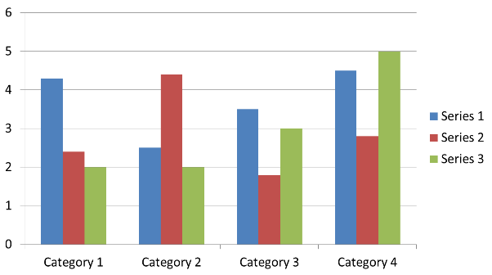

Figure 1. Figure Label

6. References
For bibliographical references, APA (American Psychological Association) style (the 6th edition) should be used (https://owl.english.purdue.edu/owl/resource/560/18/). List reference that has most important contribution, (if possible, limit to 5~10). Use 9-point Times New Roman, fully justified, single-spaced, at the end of your paper. Don’t forget to put period (.) at the end of each reference. (See examples below)

6.1. Journal Article
Author, A. A., Author, B. B., & Author, C. C. (Year). Title of article. Title of Periodical, volume number (issue
number), pages.
Harlow, H. F. (1983). Fundamentals for preparing psychology journal articles. Journal of Comparative
and Physiological Psychology, 55, 893-896.

6.2. Book
Author, A. A. (Year of publication). Title of work: Capital letter also for subtitle. Location: Publisher.
(e.g.) Calfee, R. C., & Valencia, R. R. (1991). APA guide to preparing manuscripts for journal publication. Washington, DC: American Psychological Association.

6.3. Chapter in an Edited Book

Author, A. A., & Author, B. B. (Year of publication). Title of chapter. In A. A. Editor & B. B. Editor (Eds.). Title of book (pages of chapter). Location: Publisher.
(e.g.) O’Neil, J. M. & Egan, J. (1992). Men’s and women’s gender role journeys: A metaphor for healing,
transition, and transformation. In B. R. Wiener (Ed.), Gender issues across the life cycle (pp. 107-
123). New York, NY: Springer.

6.4. Conference Proceedings

Author, A. A., & Author, B. B. (Eds.). (Year of publication). Proceedings from Title of the Conference. Location: Publisher.
(e.g.) Schnase, J. L., & Cunnius, E. L. (Eds.). (1995). Proceedings from CSCL ’95: The First International
Conference on Computer Support for Collaborative Learning. Mahwah, NJ: Erlbaum.

