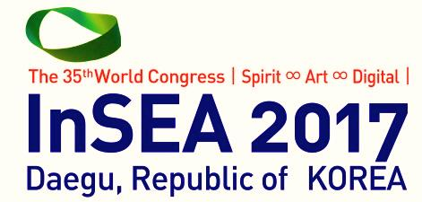
The 35th InSEA World Congress
in Daegu, Korea

Exhibition

In order to expand the base of art education research under the main theme of InSEA 2017, │Spirit ∞ Art ∞ Digtal│, InSEA 2017 exhibition covers academic and experimental works, teaching materials, student works, organizations’ or its project promotion, new digital technology.

Please note that if you apply for art education exhibition category, InSEA 2017 organizing committee will review the application and you can finally have art education exhibition.

Booth Construction
• 3mX3m 1 shell scheme booth
• Included items
- Signboard, Floor (Pytex), Information desk & 2 charis, Light (100w), Electricity (220v), Plug-in (220v, max 1kw)
• Each exhibitor should prepare for exhibit items, display stand, booth interior, promotional panel, exhibit catalog, etc.
• Exhibitors should be responsible for any damage on panels caused by gluing or nailing.

Exhibition Application Deadline April 28 (Fri), 2017

1. Art Education Exhibition

Under the main theme of InSEA 2017, │Spirit ∞ Art ∞ Digtal│, it is planned and displayed by artists and art educators joining in-school academic subjects such as teaching materials, educational or research projects, student works, and educational products based on pure research purpose in education and art field.

Price USD 1,000
Additional Benefit InSEA 2017 free registration for one person

2. Art Exhibition
Sponsor’s exhibition booths, individual or group art exhibitions, companies related to art education, art materials and new materials, related books, art textbooks, and new digital technology promotion

Price USD 3,000
Additional Benefit InSEA 2017 free registration for one person

Application Form
Exhibition Type
□ Art Education Exhibition |  |  |  |  |  | □ General Exhibition
□ Number of Exhibition Booth booth(s)
Applicant Information
Organization
Address
Name of President
Contact Person / Position
Phone Number |  |  |  |  |  |  | Mobile Number
Fax |  |  |  |  |  |  | E-mail
Website
The applicant Fully understands and agrees to the program and terms of the 35th World Congress of the Int’l Society for Education Through Art. The applicant shall pay , 100% of agreed sum within 30 days from the time of application after acceptance of the application. No refunds will be granted to application cancellation.
Date: |  |  |  | Signature:
Payment Method
Name of Bank: NongHyup Bank (NH BANK) |  |  | Account No. : 301–0192–4086-31 |  |  |  |  |  | Bank Swift code: NACFKRSEXXX
Holder: KOREAN ELEMENTARY ART EDUCATION ASSOCIATION |  |  |  |  | Bank Address: (04517) 120, Tongil-ro, Jung-gu, Seoul, Republic of Korea
Application Form Submission
Secretariat for the 35th World Congress of the Int’l Society for Education Through Art
Address: 706-803, 6F, Sunghwa B/D, #11-13, Hwarang-ro 8-gil, Suseong-gu, Daegu, 706-803, Korea
Tel: +82-53-746-9969 |  | Fax: +82-53-746-9007 |  |  |  |  |  | E-mail: insea2017@gmail.com

Application Details
Exhibition Contents (Items/required to include picture)
□ Exhibition Overview
- Name on fascia board of exhibition booth:
- Title of exhibition:
- Purpose of exhibition:

□ Exhibition items (Pictures are required)

□ Special arrangement

